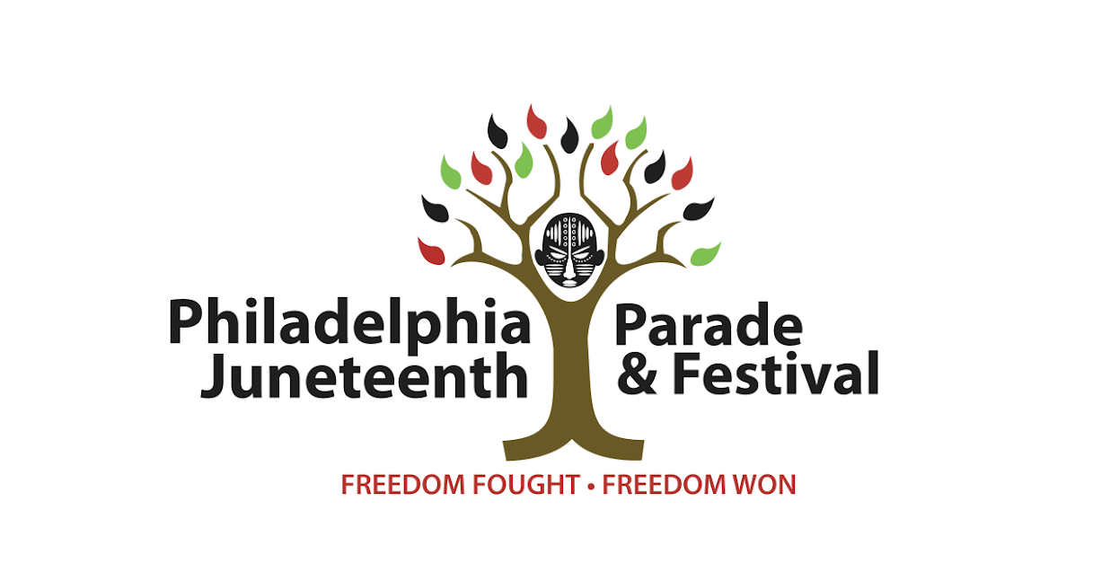
Juneteenth Vendor FAQs

Name of the Event: 2026 Juneteenth Parade & Festival

Event Date: June 21, 2026

Is the event Rain or Shine? Yes, the event is rain or shine. There will be no rain date.

Description of the Event: The Juneteenth Festival will take place on Sunday, June 21, 2026, from 12:00 PM to 7:00 PM at the historic Malcolm X Park in Philadelphia, PA. This nationally recognized event draws thousands of attendees from across the region and the country for a full day of culture, commerce, and community connection.

Is there an entrance fee for event goers? No

Is there a deadline to apply? May 21, 2026 is the deadline for Food Vendors due to health inspection application deadlines. There is no deadline for retail and resource vendors. Registration will remain open until all spots are filled.

Event Location (GPS Address): Malcolm X Park; 5100 Pine Street, Philadelphia, PA 19143

County: Philadelphia

Onsite Contact: Rachel Henry, Vendor Manager

Main Contact Email: vendors@juneteenthphilly.org

Parking Details for Food Truck: Food Truck Parking will be located on Food Truck Row which borders the park. A park map with truck placement will be provided by June 1, 2026.

Parking Details for guest/customers: There is NO designated parking for vendors or guests. Please utilize available Street Parking, however we do encourage guests to use ride share options such as Uber or Lyft. There will be designated vendor loading zones bordering the park from 7am - 11am and 7pm - 9pm.

Event Hours: 12PM-7PM

Event Fee: Free for attendees

Permitting Required (Township/County): Yes

Electricity / Plug In Capabilities: Electricity is NOT provided. However if a Vendor would like to bring a generator to have their own electricity, they must request it. Generators MUST be aligned with fire code regulations and standards.

How many guests attended in previous years? ~5,000

Estimated Guest Count: ~5,000+

Link to website and/or Facebook Page: ﻿JuneteenthphillyPennsylvania Juneteenth Pageant - Juneteenth Philly﻿

Will there be restrooms available for Staff? There are public Porta Potties available in the park for all Vendor use. Access to indoor restrooms are restricted to VIP Lounge Access members only.

Is there a dumpster available for disposable trash? There will NOT be a dumpster available. Mass Dumping IS NOT allowed. Waste management is provided by city services. Trash receptacles are changed throughout the event.

Do any of the food trucks sell seafood? This is possible if a seafood truck vendor signs up

Important Load-In Tips & Set-Up Instructions

- Bring your own dolly or hand carts to transport your items. We do not have any of these items to loan.
- You are not provided a table, chairs or a tent. You must bring your own.
- You will be given 15 Minutes to Unload. Your vehicle MUST be attended to during this time. NO EXCEPTIONS. Please come with someone that can stay with your car and help you unload.
- Unload your items and transport them to your assigned area BEFORE you begin setting up your display.
- Ensure your display does NOT spill outside of your assigned space.
- Look for staff and volunteers in grey Juneteenth shirts for assistance.
- ALL VENDORS Must be done setting up no later than 11:30AM.
- FOOD VENDORS Must be done set up by 11AM for health department inspection.
- There is NO access to water or electricity. You are allowed to bring your own generator if needed but you MUST notify us in advance.
- Once the final placement map is completed, you will be assigned a number in the park associated with your placement. The updated map and your number placement will BE EMAILED TO YOU BY JUNE 12TH.
- If you are selling ANYTHING, you must have your commercial activities license. This MUST BE EMAILED to vendors@juneteenthphilly.org no later than JUNE 10TH.
- If you are selling food OR giving out anything that can be consumed (food or beverages), you must have the required permits. This MUST BE EMAILED to vendors@juneteenthphilly.org no later than JUNE 10TH.
- Refunds will NOT be issued after Friday, June 7th for any reason.

Mandatory Vendors Meeting
All registered vendors must join a mandatory virtual Zoom meeting on Wednesday, May 27th from 6-7PM. Joining information will be provided to all registered vendors.

IMPORTANT INFORMATION REGARDING PERMITS

Food Vendors
- As per the food vending regulations of the City Of Philadelphia, Food Vendors will not be allowed onto the premises or to open their vending location without presenting the following documents:
  - A valid Food License issued by the City of Philadelphia
  - A valid Special Event Food Service Operation Eligibility Certificate issued by the City of Philadelphia. The License Eligibility Report (LER) should be taken to the Office of Licenses and Inspections located at 1401 JFK Blvd.
  - Vendors with restaurants must have a current satisfactory health inspection report in order to be eligible to participate in events.

For more information about food vending / food protection, contact the Philadelphia Health Department at (215) 685-7490, and or download and review the forms you and / or vendors may need at http://www.phila.gov/health//permitsForms.html.

- All Food Vendors must comply with all City, State, County, and Federal regulations and actively follow all prescribed guidelines for the handling, preparation, sale, storage, and disposal of their food items.

Retail Vendors
- The sale of items containing tobacco (e.g., cigarettes, cigars, chew, etc.), illegal substances, and illegal substance paraphernalia is strictly prohibited.
- The sale of counterfeit or bootleg merchandise is prohibited.

- Vendors will refrain from selling items that may harm visitors or will cause excess litter and damage to Parks and Recreation owned or operated property. Prohibited items include stickers, air-horns, confetti, silly string, snap pops, and pyrotechnic and incendiary devices such as sparklers, fireworks, firecrackers, and cherry (smoke) bombs.

- Vendors must have Philadelphia Commercial Activity License https://www.phila.gov/services/permits-violations-licenses/get-a-license/business-licenses/activity/get-a-commercial-activity-license/

